A Project Report on

**PROJECT BASED LEARNING**

ON

**ARDUINO**

*Submitted By:*

Swaroop Bharaskar

Tejas Godse

Sarvesh Shirude

Sanket Sutar

Sarvesh Tilekar

In

Department of Electrical Engineering

(SEMESTER – IV)



Of

**Pune Vidhyarthi Griha's College of Engineering and Technology**

**affiliated with the University of Pune**

**TEAM I PROJECT REPORT**

Project Based Learning (PBL) is a student centered and experimental approach to education promoting deeper learning through active exploration of real world problems and challenges

* **OBJECTIVES OF PBL**

Objectives of this course are to

1. Impart technical knowledge and skills, and develop deeper understanding to integrate knowledge and skills from various areas.

2. Build critical thinking, problem-solving, communication, collaboration and creativity, and innovation amongst students

3. Make students aware of their own academic, personal, and social developments.

4. Develop habits of self-evaluation and self-criticism, against self-competency and trying to see beyond own ideas and knowledge

* **PIN DIAGRAM OF ARDUINO**

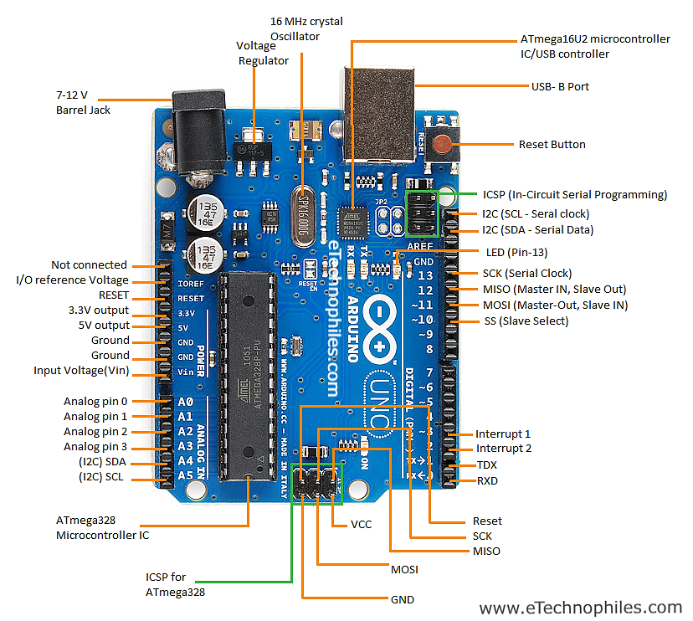

**Defining Arduino Uno:**

An Arduino is actually a microcontroller based kit which can be either used directly by purchasing from the vendor or can be made at home using the components, owing to its open source hardware feature. It is basically used in communications and in controlling or operating many devices.

* Digital pins: 14 (These pins have only 2 states i.e. high or low or in simple words either 5 V or 0 V no in between values. These pins are mostly used to sense the voltage presence when switch is open or close)
* Analog pins: 6 (A0 to A5 and they come up with a resolution of 10 bits and they provide flexibility of connecting any external device via these pins. These pins are configured from 0 V to 5 V but they can be configured to high range by using AREF pin or analogReference () function. ADC (analog to digital convertor) is used to sample these pins. These pins take analog signal and by using ADC convertor they convert this analog signal to number between 0 – 1023)
* 16 MHz crystal oscillator
* Out of 14 digital pins, 6 can be used for PWM (pulse width modulation)
* USB port
* TX and RX pins (for serial communication)
* **Arduino** is an open-source hardware and software company, project and user community that designs and manufactures single-board microcontrollers and microcontroller kits for building digital devices. Its products are licensed under the GNU Lesser General Public License (LGPL) or the GNU General Public License (GPL), permitting the manufacture of Arduino boards and software distribution by anyone. Arduino boards are available commercially in preassembled form or as do-it-yourself (DIY) kits.
* Arduino board designs use a variety of microprocessors and controllers. The boards are equipped with sets of digital and analog input/output (I/O) pins that may be interfaced to various expansion boards ('shields') or breadboards (For prototyping) and other circuits. The boards feature serial communications interfaces, including Universal Serial Bus (USB) on some models, which are also used for loading programs from personal computers. The microcontrollers can be programmed using C and C++ programming languages. In addition to using traditional compiler toolchains, the Arduino project provides an integrated development environment (IDE) based on the Processing language project.
* **List Of Components, their specifications and costing**

|  |  |  |
| --- | --- | --- |
| **Components** | **Specifications** | **Costing** |
| Arduino Uno | It is an ATmega328P based Microcontroller | ₹700 |
| Breadboard | Dimension is 6.5*4.4*0.3 inch.  Rating is 5Amps | ₹80 |
| Connecting Wires | Male to Male  Female to Female  Male to Female | ₹50 |
| LED Red, Green & Multicolour | 3.5 Volts | ₹16 |
| Analog Pot | 1k Ohms | ₹10 |
| LM35 | Operates from 4to 30 V.  −55°C to 150°C Range. | ₹60 |
| Resistor | 1K and 220V | ₹18 |
| Uno cable | USB 2.0 Cable Type A/B | ₹40 |
| Buzer | Frequency range is 3,300Hz.  Sound pressure level is 85dBA or 10cm.  3V to 24V DC | ₹10 |
| IR sensor | VDC 3.6 ~ 5  Distance Measuring Range 2 ~ 30 cm | ₹60 |
|  |  | Total - ₹1044 |

* **Arduino UNO board is used in the following applications.**
* Weighing Machines
* Traffic Light Count Down Timer.
* Parking Lot Counter
* Embedded systems.
* Home Automation
* Industrial Automation
* Medical Instrument.
* Emergency Light for Railways.
* **Advantages**
* Ready to Use:
* Inexpensive
* Open source in hardware
* Easy programming language
* Open source in software
* IDE Software operates on any operating system
* **Disadvantages**
* Processing power is weaker than microcontroller
* Cannot run more than one program at the same time.
* No memory safety checks
* Expensive for the CPU power and memory.
* Lack of built-in communications.
* Lack of built-in peripherals.
* Limited number of programming languages.
* Limited number of IDEs
* **Outcome**
* At the end of PBL we are able to identify formulate and analyse the programs related with Arduino
* We are able to apply knowledge of mathematics basic science fundamentals of electrical engineering and C/C++ languages.
* Learned to work in team and to carry out different task that are required during a project
* Understand our own and our teammates strengths and skills
* Draw information from variety of sources and we are able to filter and summarize the relevant points
* Communicate to different audiences in oral, visual and written form
* **Conclusion**
* The pbl activity was taken on two days 12 and 13 of April by Prof. gauri karve and prof. S.h. yamalla. On 12th of April prof yamalla gave us the information related to arduino in which he gave a brief explanation on arduino. What is arduino, what are its various parts, what are its function, advantages and disadvantages of it, how many ports pins it consist of, what are the components from which arduino is made up of ,which all components we will be using in this 2 days course, various application of it, how can we use arduino in our day to day life, how to do programming on it, which all projects we will be doing in this course.
* On the second day that is on 13th of April we did hands on with the arduino and performed its various applications. To run all the different programs we used Arduino IDE i.e integrated development environment which was new to us.
* We did various applications out of which some of them are:-

1. Single led blink:- in which we studied how led can be blinked using arduino
2. LED blinking with different patterns:- in this LED’s were blinked with n number of patters such as even odd led blinking.
3. Serial Communication:- in this we received the data serially and transmitted it back to the monitor. We set the baud rate to 9600. The baud rates signifies the data rate in bits per second
4. LCD display:- in this we did data representation on LCD display i.e liquid crystal display using library called liquidcrystal.h file.
5. Temperature monitoring using LM35:- LM35 is a temperature sensor which senses the temperature from -55 degree Celsius to +150 degree Celsius.

In this we calibrated the temperature using a formula i.e

(4.00 * analogRead(A0) * 100) / 1023.0

And we displayed the output on serial monitor of ardino IDE

1. Temperature monitoring using LM35 in LCD:- in this we did the same procedure as above mentioned but in this we displayed the output on LCD
2. DC Motor interface:- In this we controlled the dc motor using arduino commands. We rotated the DC motor in clockwise and anticlockwise direction with different speeds

* **Vote of Thanks**

On behalf of team I, we would like to thank our department of Engineering for conducting this Training programme on “Hands on with Arduino”. The sessions which was taken were full of knowledge and practical application. It will really help us for building future projects!! A special thanks to Prof. Gauri Karve maam for taking the initiative for organizing the course and thanks to Prof. Mandar Bhawalkar for guiding us throughout the project.